Experiment 1 - Clock and Periodic Signal

Generation

Amirarsalan Shahbazi a\*, Mohammad Hossein Mazhari b

a *B.A Student, Department of Computer Engineering, University of Tehran, Tehran, Iran.*

\*Corresponding author: Email: shahbaziarsalan@ut.ac.ir. Student ID: 810101451

b *B.A Student, Department of Computer Engineering, University of Tehran, Tehran, Iran.*

Email: smh.mazhari@ut.ac.ir. Student ID: 810101520

I. Ring Oscillator

*A. Briefly explain the experiment procedure.*

Main purpose of this section is to calculate logic gates delay by means of calculate delay of odd number of gates and then divide whole delay by number of gates.

Another purpose of this section is to generate a clock using IC. The clock that is generated here does not have a squared waveform and it is similar to sin waveform.

The experiment starts from wiring five of the six inverters of 74HCT04 IC to each other and wire the last one to the first one. This can be done by wire each two inverters needed using wires and a breadboard. Here we wired all inverters except one. So, number of gates used is five.

After calculating the delay, we divide the delay by 2 \* 5 to calculate each inverter delay.

*B. Report the observed waveform along with the measured frequency of the chain.*

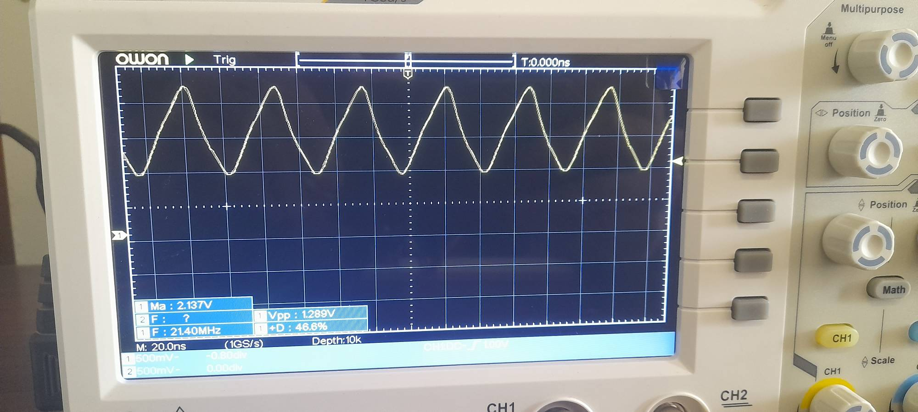

Fig. 1 Waveform of the output of the circuit is shown above whereas it can be seen the measured frequency is 21.4MHz

Waveform of this circuit (Fig. 1) is not squared and it looks like sin waveform.

*C. Report the propagation delay of the chain.*

We measure propagation delay by measuring the period time of the output.

We know that $T=\frac{1}{F}$ so propagation delay will be $\frac{1}{F}= \frac{1}{21.4MHz}=4*{10}^{-9}$ s.

D. Calculate the delay of a single inverter.

Recall that circuit delay = 2N ∗ Delay inv, so delay inv = $\frac{4*{10}^{-9}}{2(5)}= 4*{10}^{-10}$ s.

II. LM555 Timer

*A. Briefly explain the experiment procedure.*

In this part we want to generate a clock with rectangular pulse. In previous part we learned how to generate a clock but its form was not important to us so we saw a non-rectangular pulse waveform. Here we try to generate a clock which is in rectangular form so in continue our measurements can be easier. In this section we work with another IC called LM555 in Astable mode.

This IC has two resistors and two transistors and with increasing the R2 resistor we try to calculate duty cycle and at the end we conclude our observations.

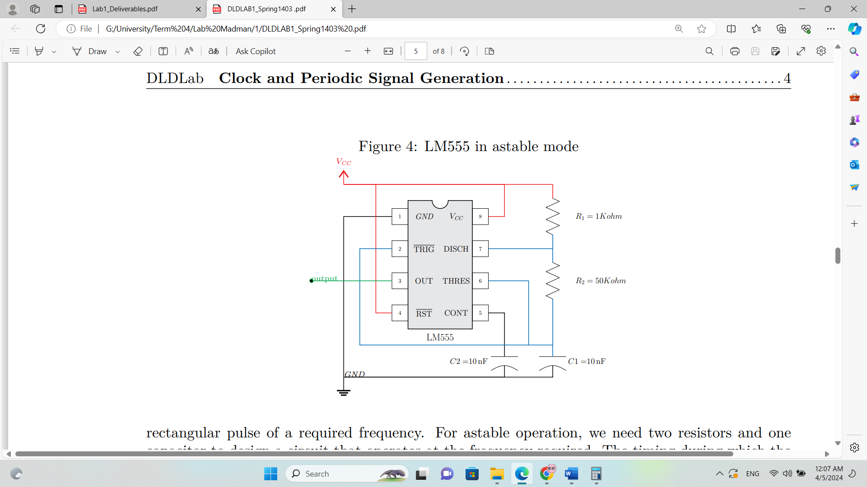

Fig. 2 LM555 in Astable mode

*B. For all three cases of R2 resistor: Include the waveform along with the measured frequency and duty cycle. Using the equations provided in the manual, calculate the expected frequency and duty cycle to verify your measurement.*

*1)R2 =* *1kΩ*

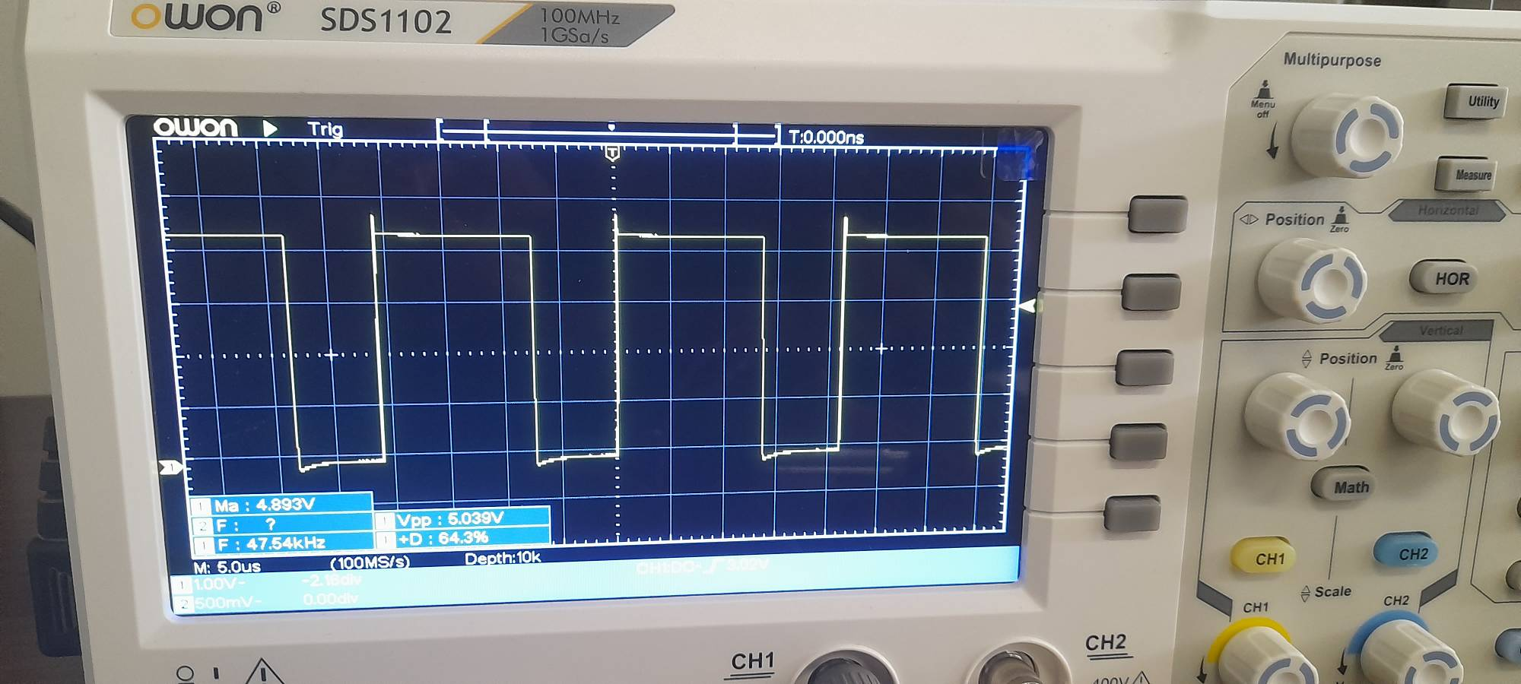

Fig. 3 Waveform of the circuit (Fig. 2) with R2 = 1kΩ

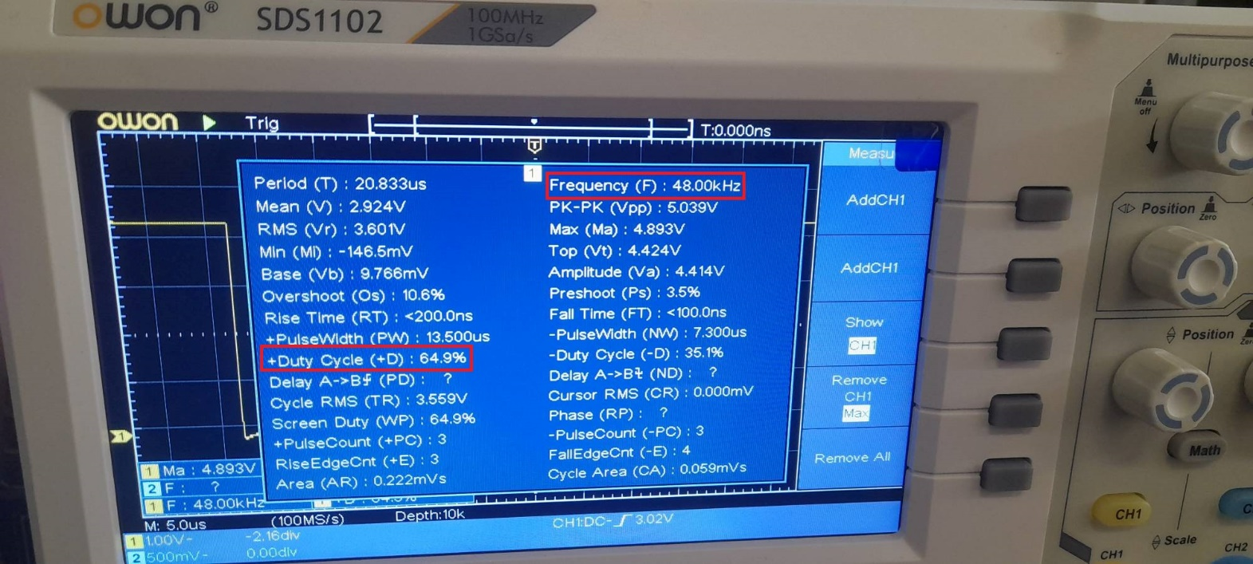

Fig. 4 Duty cycle and frequency of R2 = 1kΩ circuit (Fig. 2).

The duty cycle can also be computed by $\frac{R1+R2}{R1+2R2}=Duty Cycle= 66\%$ which is close to Fig. 4 result.

The frequency can be computed by T = 0.693 \* (R1+2R2) \*C = $2.079*{10}^{-5}$ => F = 48.10kHz which is so close to our observation.

*2)R2 = 10kΩ*

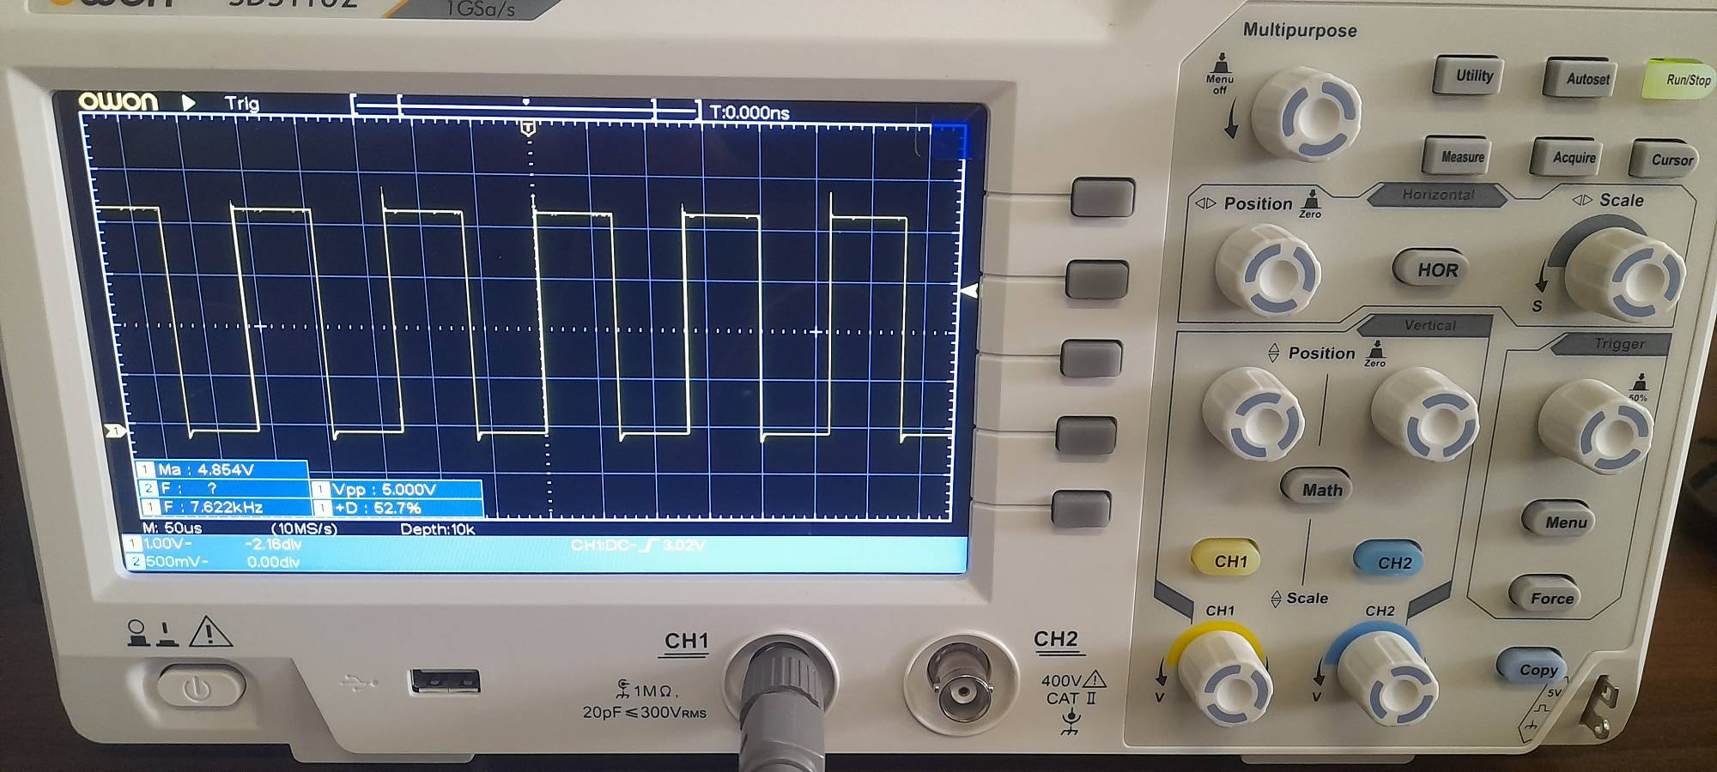

Fig. 5 Waveform of the circuit (Fig. 2) with R2 = 10kΩ

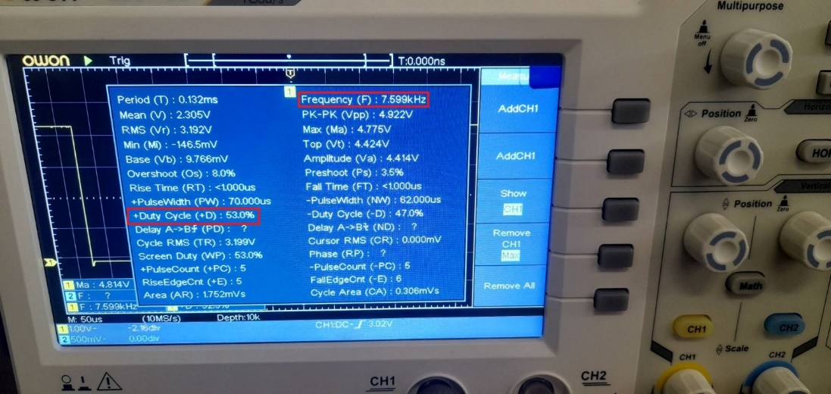

Fig. 6 Duty cycle and frequency of R2 = 10kΩ circuit (Fig. 2).

The duty cycle can also be computed by $\frac{R1+R2}{R1+2R2}=Duty Cycle= 52\%$ which is close to Fig. 6 result.

The frequency can be computed by T = 0.693 \* (R1+2R2) \*C = $14.553*{10}^{-5}$ => F = 6.87kHz which is close to our observation.

*3)R2 = 100kΩ*

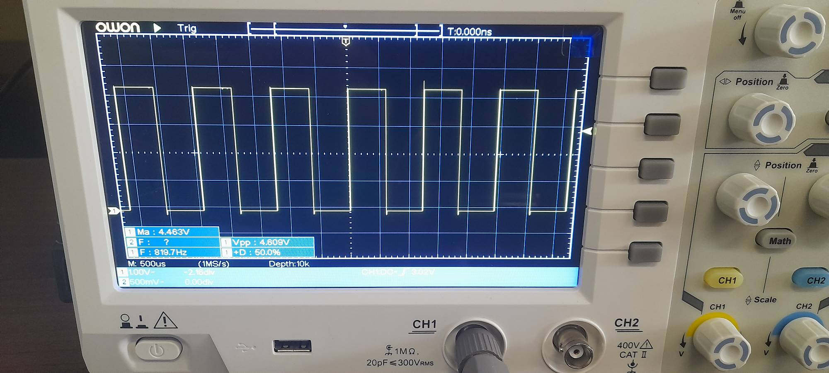

Fig. 7 Waveform of the circuit (Fig. 2) with R2 = 100kΩ

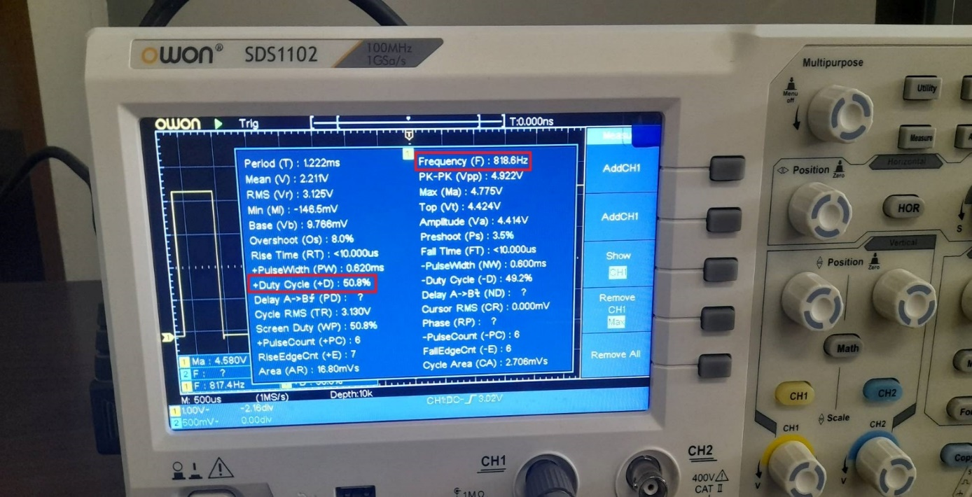

Fig. 8 Duty cycle and frequency of R2 = 100kΩ circuit (Fig. 2).

The duty cycle can also be computed by $\frac{R1+R2}{R1+2R2}=Duty Cycle= 50.2\%$ which is close to Fig.8 result.

The frequency can be computed by T = 0.693 \* (R1+2R2) \*C = $139.293*{10}^{-5}$ => F = 717Hz which is close to our observation.

*C. Explain the changes in the duty cycle by varying the resistor R2.*

As we computed above and observe result of our experiment, we see that with increasing the resistor 1 our duty cycle lowers from 66% to 50%. Note that increasing R2 more than a certain amount does not change our duty cycle when we are already achieved 50% because if R2 is high enough we can ignore R1 which is very low in compare to R2 and we always get $\frac{R2}{2R2}=50\%$.

III. Schmitt Trigger Oscillator

*A. Briefly explain the experiment procedure.*

In this section we are working with 74HCT14 IC which has the Schmitt inverter and our purpose is that to show the waveform of the output of this circuit including its frequency and then compute α with given formula and with different resistors.

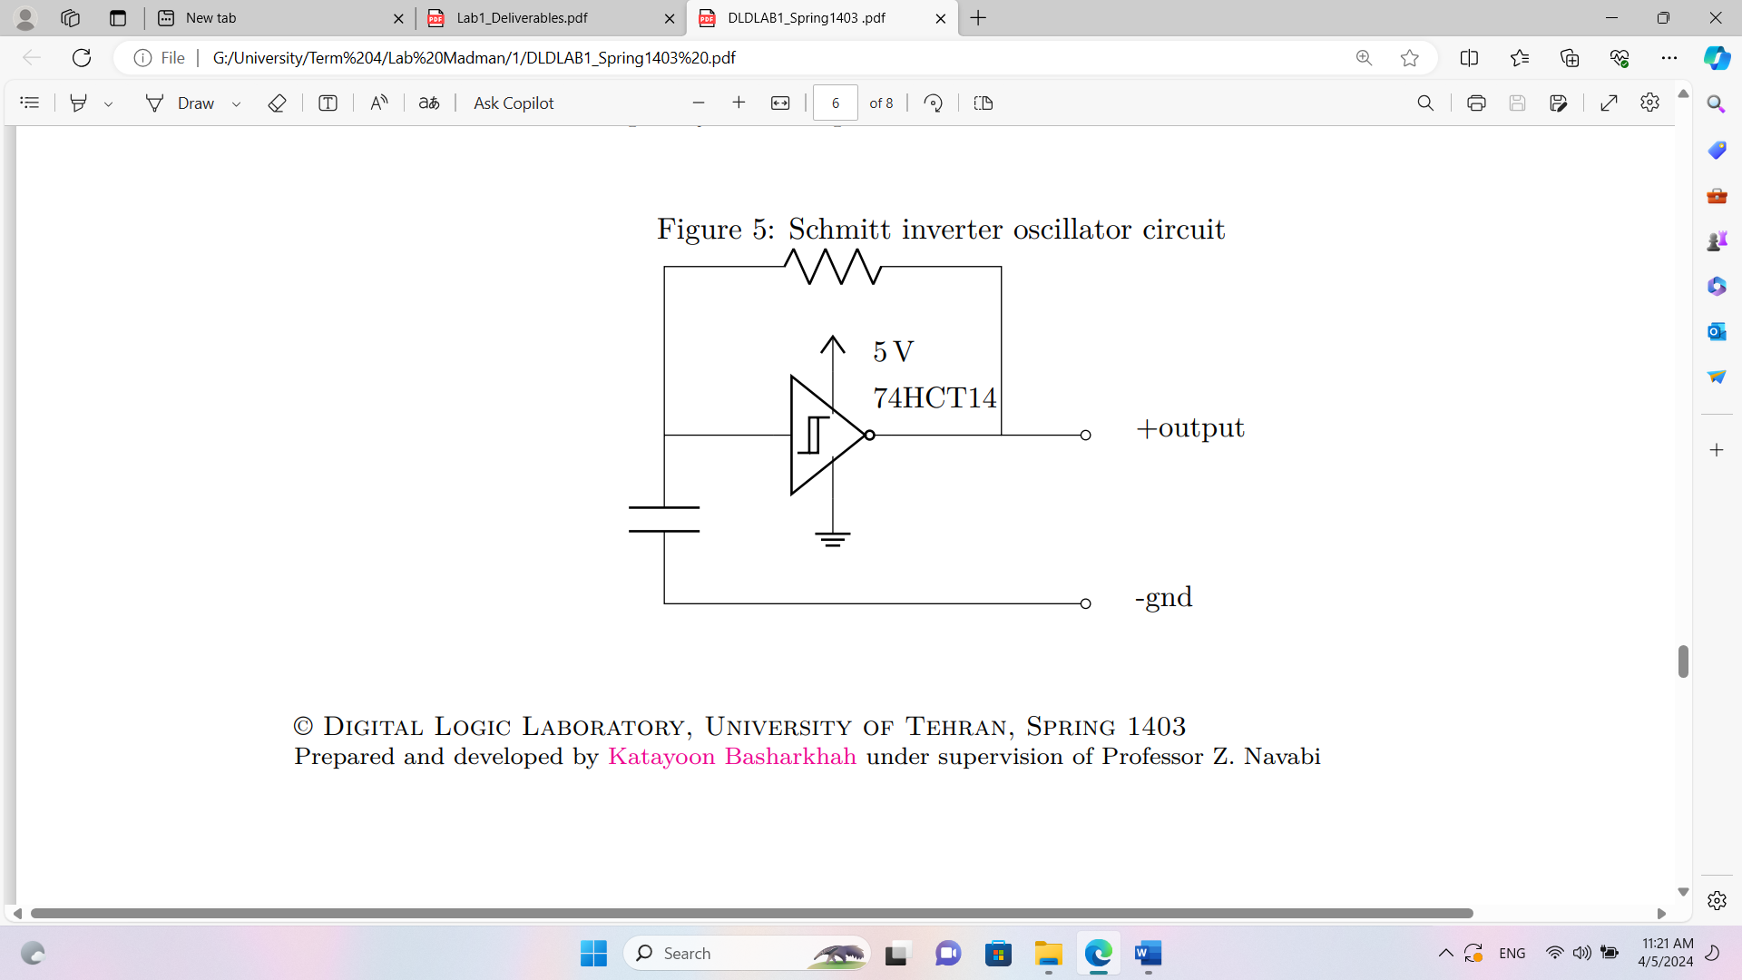

Fig. 9 Schmitt inverter oscillator circuit

*B. Report the output frequency and calculate the α parameter for all three values of the resistor.*

*1)R = 470Ω*

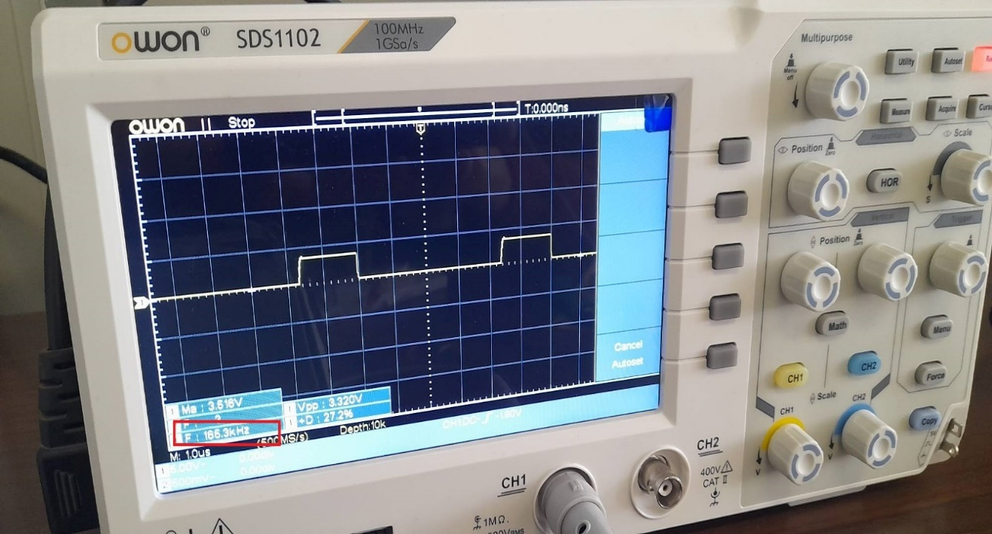

Fig. 10 Waveform for circuit (Fig. 9) with R = 470Ω with its frequency shown.

We know that $α= fRC therefore α=165kHz*RC=0.77$.

*2)R = 1000Ω*

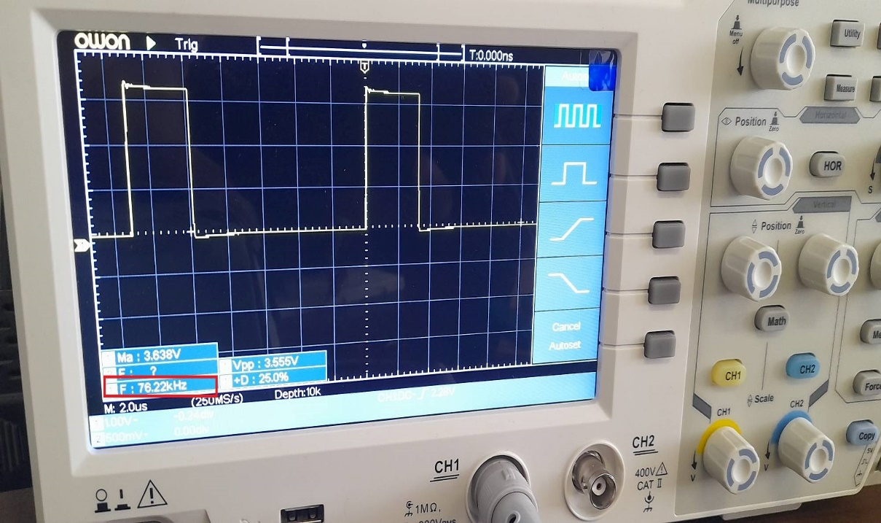

Fig. 11 Waveform for circuit (Fig. 9) with R = 1000Ω with its frequency shown.

We know that $α= fRC therefore α=76kHz*RC=0.76$.

*3)R = 2200Ω*

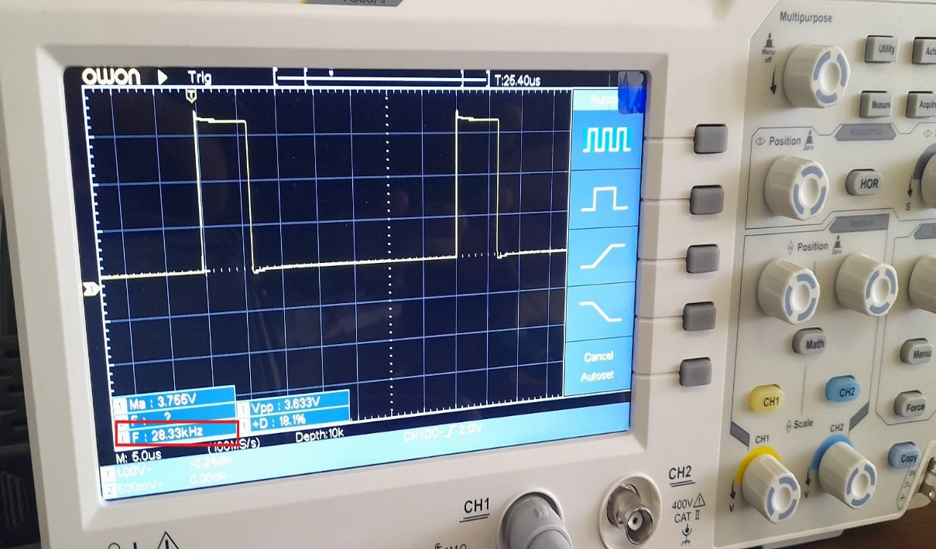

Fig. 12 Waveform for circuit (Fig. 9) with R = 2200Ω with its frequency shown.

We know that $α= fRC therefore α=28kHz*RC=0.62$.

*C. Report the average α.*

The average α is $\frac{0.77+0.76+0.62}{3}=0.71 .$

IV. Synchronous Counter as a Frequency Divider

*A. Briefly explain the experiment procedure.*

In this section our purpose is to first, generate a clock (Here we used ring oscillator of part 1) and then making a counter which is used as a frequency divider.

B. Explain how can one determine the Parallel Input values of each counter.

We use this formula to initialize the counter: Initial value = Maximum value – Modulus (where as Modulus is 200)

We have two 4bit counters. To make 200, we need both of them and we should connect them properly (such that the carry out of the LSB counter should run the MSB counter).

And we have a part for presetting and initializing the counters as shown in Fig. 13.

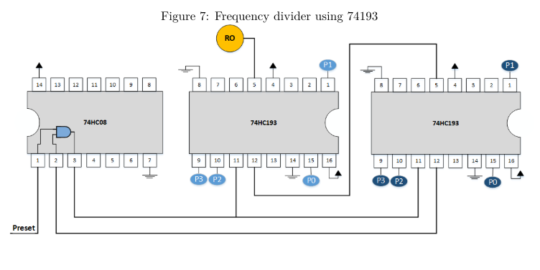

Fig. 13 Frequency divider using 74193

After connecting the elements correctly, we use a TFF to produce a 50 percent duty cycle signal.

*C. Explain the presetting mechanism used in the circuit.*

We should preset the circuit once. So, we have a preset signal and an and gate with the input signal to preset just when we want to.

*D. Report the observed waveform of the circuit output (MSB carry out) along with the measured frequency.*

Now as we have in Fig. 14, the output frequency is 147.3 KHz. The input frequency is nearly divided by 200. (Input is 40 MHz and now output is 147.3 KHz.)

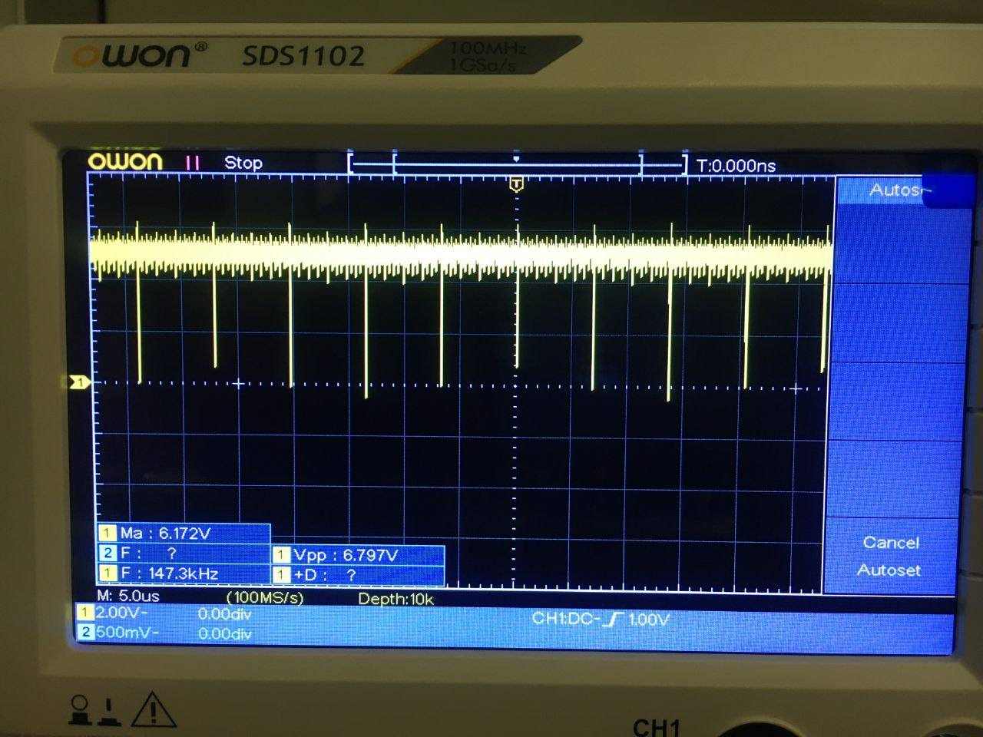

Fig. 14 Waveform of the output of our frequency divider.

*E. Compare the output frequency with the Ring Osc. frequency and discuss the observed changes in the duty cycle.*

The input frequency is nearly divided by 200. As shown in Fig. 15, input is 40 MHz and now output is 147.3 KHz.

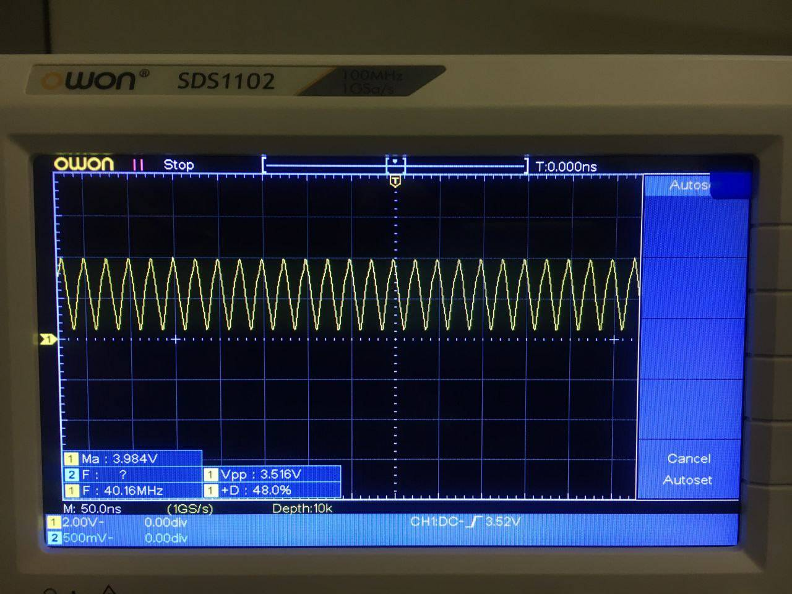

Fig. 15 Waveform of the input of our frequency divider which is Ring Oscillator output.

As shown in Fig. 13, the input duty cycle is 48%, but after passing the circuit, it changes to some percent that is far from 50%.

V. T Flip-Flop

*A. Briefly explain the purpose of using TFF.*

We use a T Flip-Flop after the counter to produce a 50 percent duty cycle signal. Actually, we use a D Flip-Flop, 74HC74 IC, and convert it to a T Flip-Flop.

To convert DFF to TFF we assign Qbar = D.

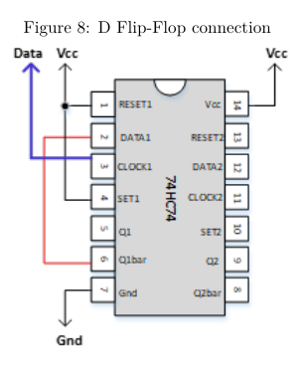

Fig. 16 D Flip-Flop connection

*B. Measure the output frequency and compare it with its input and the Ring Osc. frequency.*

According to the measurements:

The input frequency was 40 MHz and the ring Oscillator frequency was 147.3 KHz. (It is $\frac{1}{200}$ input frequency)

The output frequency was 73.5 KHz. (It is almost half of ring Oscillator frequency as expected)

As we see below the duty cycle is almost 50%.

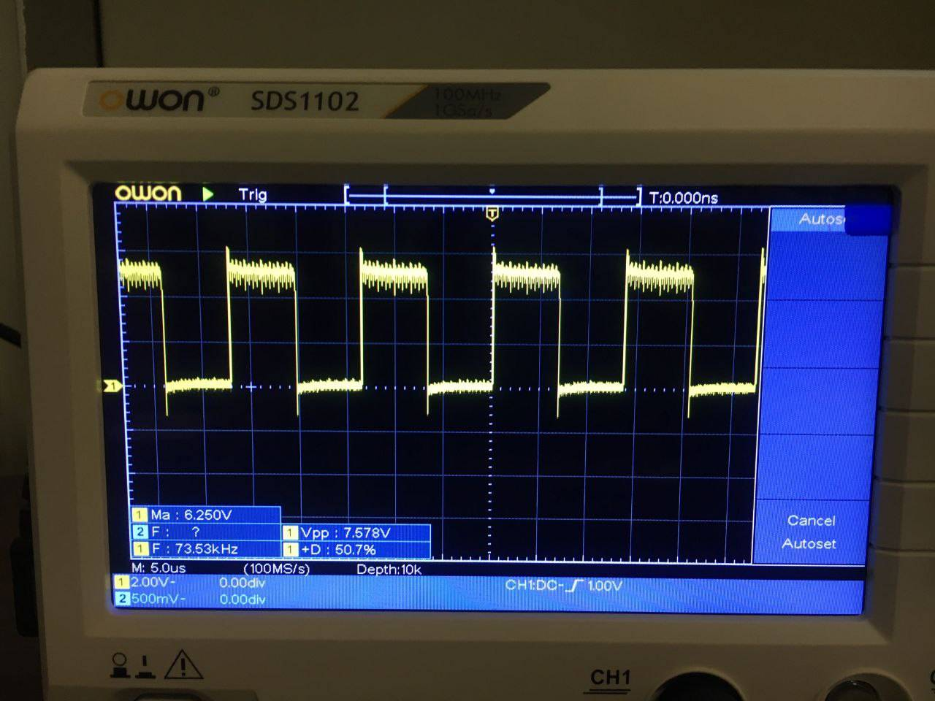

Fig. 17 Waveform of the circuit after using TFF. (The duty cycle is 50.7% and the frequency is 73.5 KHz.)